# Burnett Youth Learning Centre Annual Report 2025 (Based on 2024 data)

## Contextual Information[1]

### School Sector: *

|  |
| --- |
| Independent |

### Year Levels Offered:

|  |
| --- |
| While BYLC students are ungraded, age equivalence to years 7 - 12 are offered. |

### Co-educational or Single Sex: *

|  |
| --- |
| Co-educational |

### Characteristics of the Student Body: *

|  |
| --- |
| All BYLC students have disengaged from formal education and have been referred to the Learning Centre. Percentages fluctuate, but approximately 28% of BYLC’s student body are indigenous students, 15% are students with verified disabilities (using ISQ verification definition) however, approximately 84% require supplementary, substantial or extensive adjustments for other disabilities or disorders using the NCCD definitions. 33% are female. |

### Total Enrolments: *

|  |
| --- |
| 106 |

## Workforce Information

### Workforce Composition, Including Aboriginal and Torres Strait Islander Staff: *[2]

|  |
| --- |
| The Learning Centre’s full-time equivalent staffing is:  Teachers = 35%  Trainers = 28%  Student Support = 10%  Administration = 21%  Auxiliary = 6%  We have two indigenous staff members |

### Qualifications of all Teachers: *[3]

|  |  |
| --- | --- |
| **Qualification** | **Detail the number and/or the percentage of classroom teachers and school leaders at the school who hold this qualification** |
| Doctorate or higher | 0% |
| Masters | 15% |
| Bachelor | 33% |
| Diploma | 10% |
| Certificate | 42% |

### Funding Information

### School Income Broken Down by Funding Source *[4]

|  |
| --- |
| School Income:  School funds are provided by the State and Federal Governments and supplemented by income generated by the farm and enterprise projects |

### Social Climate

### Parent, Student and Teacher Satisfaction with the School *[5]

|  |
| --- |
| Satisfaction Data:  BYLC conducts a Parent/Carer survey on an annual basis. The results of the most recent survey can be seen below. The information in these surveys is confidential as names or contact details are not requested. This is another opportunity for the school community to provide their feedback on the different aspects of the program to inform BYLC of areas that need addressing. |

## Student Outcomes

**2024 Parent /carer Survey**

**Rating Score:** Strongly agree 5

Agree 4

Neither agree or disagree 3

Disagree 2

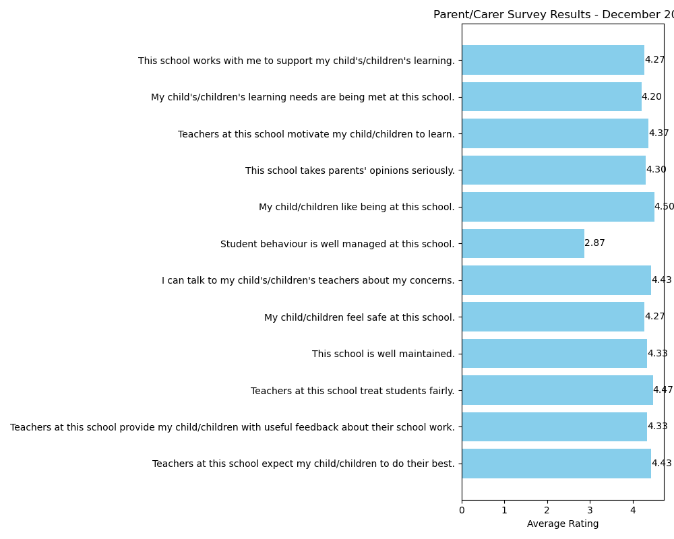 Strongly disagree 1

### Average student attendance rate (%) for the whole school: *[6]

|  |
| --- |
| The average student attendance rate for the whole school in 2024 was __69__% |

### Average student attendance rate for each year level: *[7]

|  |  |
| --- | --- |
| (Year Group (etc.) | % |
| **Note: Burnett Youth Learning Centre is an upgraded school and as such the average attendance rate for each level is not applicable.** |  |

**A description of how non-attendance is managed by the school**: *[8]

|  |
| --- |
| Non-attendance at BYLC can be a reflection of student marginalisation, mental health concerns or external capacity. Reasons for non-attendance are many and varied but treated with high importance. Administration staff, student support staff and the Centre Principal [together with the Centre’s bus drivers] form a cohesive team to address student absenteeism. Absentee phone calls are made daily. Four absent days without reason are followed up by a Chaplain and/or Connect Coaches. Prolonged absences are followed up by the Principal, Youth Worker and/or administration correspondence. Department of Child Safety “Mandatory Reports” can be made and possible disenrollment after due process. Generally, a high level of support is offered to non-attenders and their families as BYLC seeks to maintain student attendance incentives and improvement. Student attendance incentives are offered as encouragement and are regularly communicated to parents/carers/guardians and students. |

**Non-attendance at BYLC can be a reflection of student marginalization, mental health concerns or external capacity. Reasons for non-attendance are many and varied but treated with high importance. Administration staff, student support staff and the Centre Principal [together with the Centre’s bus drivers] form a cohesive team to address student absenteeism. Absentee phone calls are made daily. Four absent days without reason are followed up by a Chaplain and/or Connect Coaches. Prolonged absences are followed up by the Principal, Youth Worker and/or administration correspondence. Department of Child Safety “Mandatory Reports” can be made and possible disenrollment after due process. Generally, a high level of support is offered to non-attenders and their families as BYLC seeks to maintain student attendance incentives and improvement. Student attendance incentives are offered as encouragement and are regularly communicated to parents/carers/guardians and students.**

## NAPLAN results for Years 3, 5 and 7 and 9 in 2024 *[9]

## Benchmark Data for Year

|  |  |  |  |  |
| --- | --- | --- | --- | --- |
| **Results**  The average NAPLAN score for all students at the school in each domain, compared to the average score of students in Australia for that domain | | | | |
| **Reading** | | | | |
|  | Year 3 (2024) | Year 5 (2024) | Year 7 (2024) | Year 9 (2024) |
| Average Score (School) |  |  |  |  |
| Average Score (National) | 404 | 492 | 535 | 565 |
| **Writing** | | | | |
|  | Year 3 (2024) | Year 5 (2024) | Year 7 (2024) | Year 9 (2024) |
| Average Score (School) |  |  |  |  |
| Average Score (National) | 416 | 485 | 540 | 574 |
| **Spelling** | | | | |
|  | Year 3 (2024) | Year 5 (2024) | Year 7 (2024) | Year 9 (2024) |
| Average Score (School) |  |  |  |  |
| Average Score (National) | 401 | 486 | 540 | 567 |
| **Grammar and Punctuation** | | | | |
|  | Year 3 (2024) | Year 5 (2024) | Year 7 (2024) | Year 9 (2024) |
| Average Score (School) |  |  |  |  |
| Average Score (National) | 409 | 498 | 537 | 555 |
| **Numeracy** | | | | |
|  | Year 3 (2024) | Year 5 (2024) | Year 7 (2024) | Year 9 (2024) |
| Average Score (School) |  |  |  |  |
| Average Score (National) | 404 | 489 | 540 | 565 |
| **Burnett Youth Learning Centre’s parents/carers/guardians opted to withdraw their children, sighting reasons as “other” with additional notes such as “mental health” and “do not believe in standardized testing” within their withdrawal forms. The majority of BYLC students consistently rate below the National minimum standard in Reading, Writing, Spelling, Grammar, Punctuation and Numeracy due to educational disengagement and/or cognitive capacity. Language, literacy and numeracy (LLN) education remains a critical area for effort and student support.** | | | | |

### Year 12 Outcomes: *[10]

|  |  |
| --- | --- |
| **Outcomes for our Year 12 cohort 2024** | |
| Number of students awarded a Senior Education Profile | 15 |
| Number of students awarded a Queensland Certificate of Individual Achievement | 0 |
| Number of students who received an ATAR | 0 |
| Number of students who are completing or completed a School-based Apprenticeship or Traineeship (SAT) | 1 |
| Number of students awarded one or more Vocational Education and Training (VET) qualifications | 8 |
| Number of students awarded a Queensland Certificate of Education at the end of Year 12 | 0 |
| Number of students awarded an International Baccalaureate Diploma (IBD) | 0 |
| Percentage of Year 12 students who received an ATAR above 90 | 0% |
| Percentage of Year 12 students who are completing or completed a SAT or were awarded one or more of the following: QCE, IBD, VET qualification | 53% |
| Percentage of Queensland Tertiary Admissions Centre (QTAC) applicants receiving a tertiary offer | 0% |

### Post-school Destination Information*[11]

|  |
| --- |
| At the time of publishing this School Annual Report, the results of the 2024 post-school destinations survey, *Next Steps – Student Destination* report for the school was not available. Information about these post-school destinations of our students will be uploaded to the school’s website in September after release of the information. |

1. *Australian Education Regulation 2023 s60 (1)(a)*
2. *Australian Education Regulation 2023 s60 (1)(c)*
3. *Australian Education Regulation 2023 s60 (1)(b)*
4. *Australian Education Regulation 2023 s60 (1)(g)*
5. *Australian Education Regulation 2023 s60 (1)(f)*
6. *Australian Education Regulation 2023 s60 (1)(d)*
7. *Australian Education Regulation 2023 s60 (1)(d)(i)*
8. *Australian Education Regulation 2023 s60 (1)(d)(ii)*
9. *Australian Education Regulation 2023 s60 (1)(e)*
10. *Australian Education Regulation 2023 s60 (1)(h)(i)*
11. *Australian Education Regulation 2023 s60 (1)(h)(ii)*